Creating static External IP

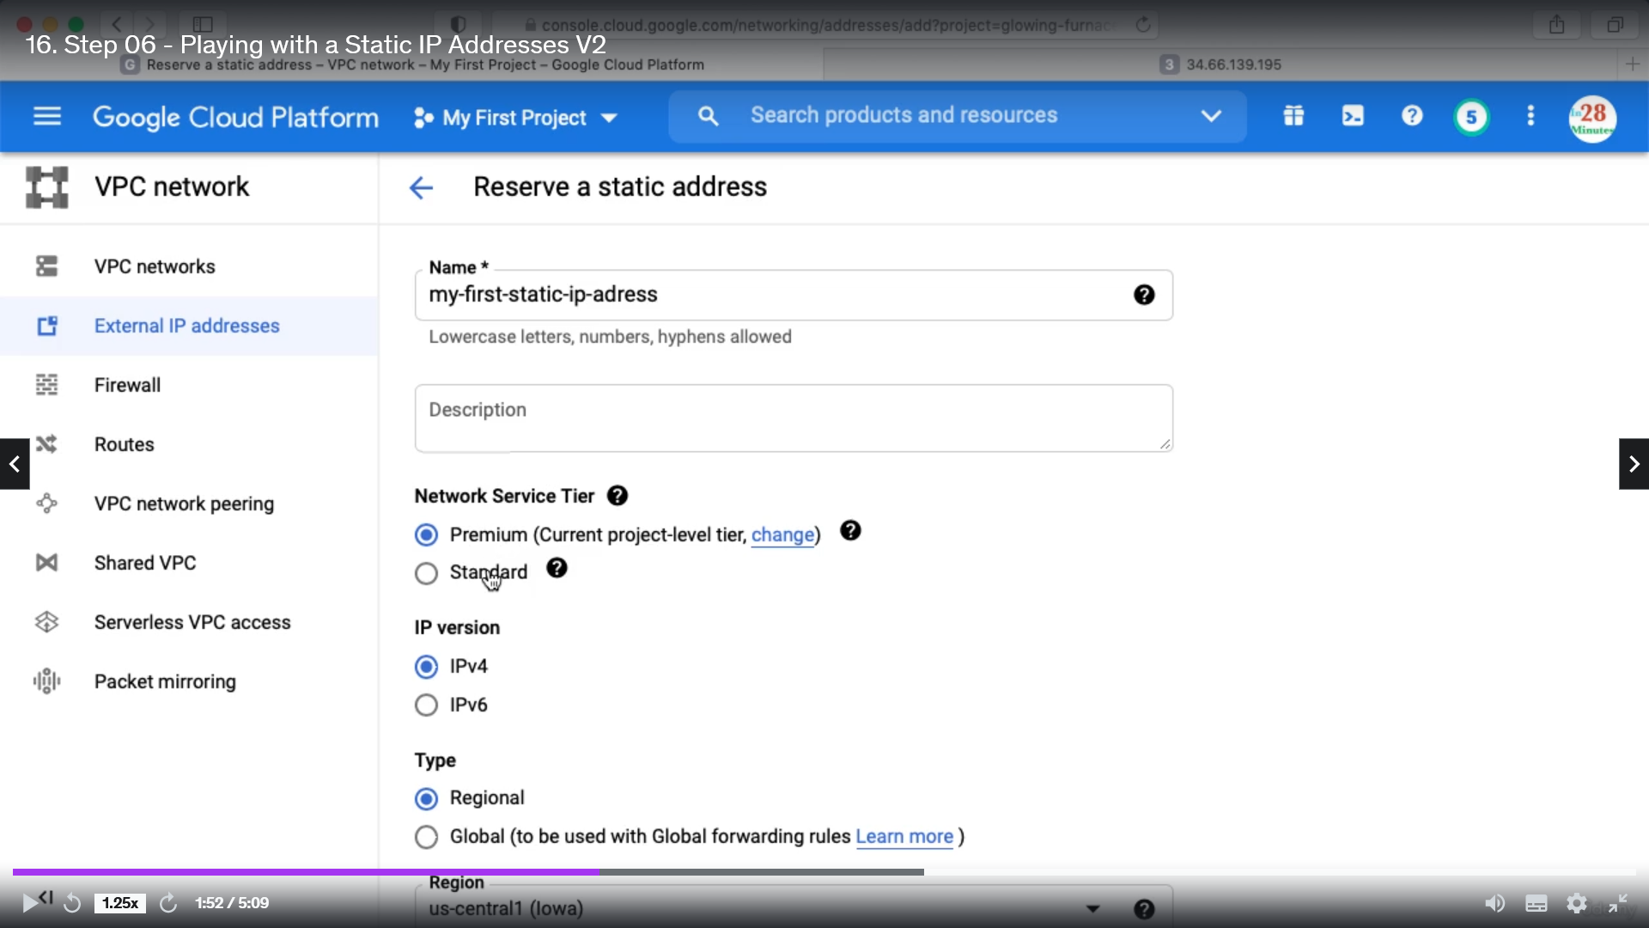

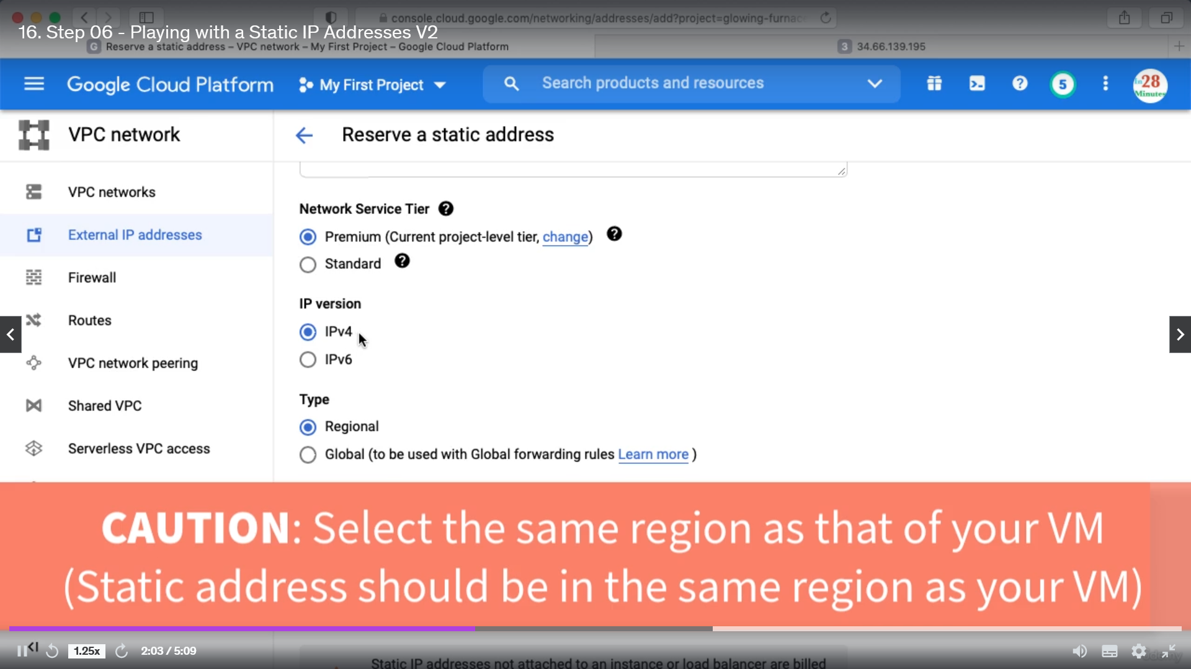

Then click create. And static IP will be created like below  
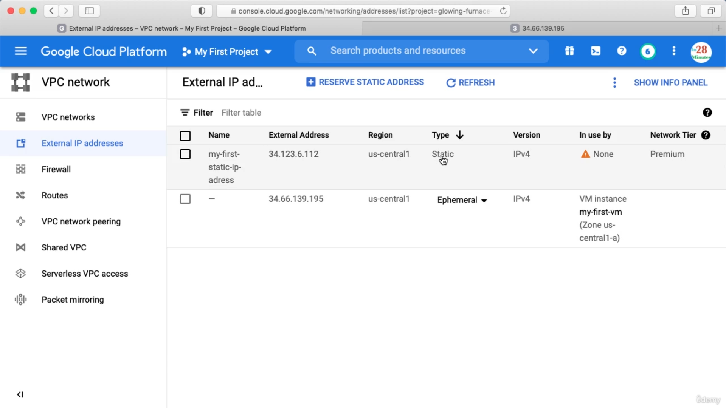

Ephemeral means changeable.

Assign Static Ip to VM. Click the change button  
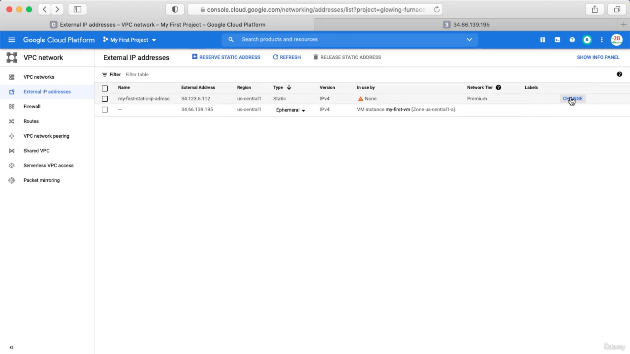

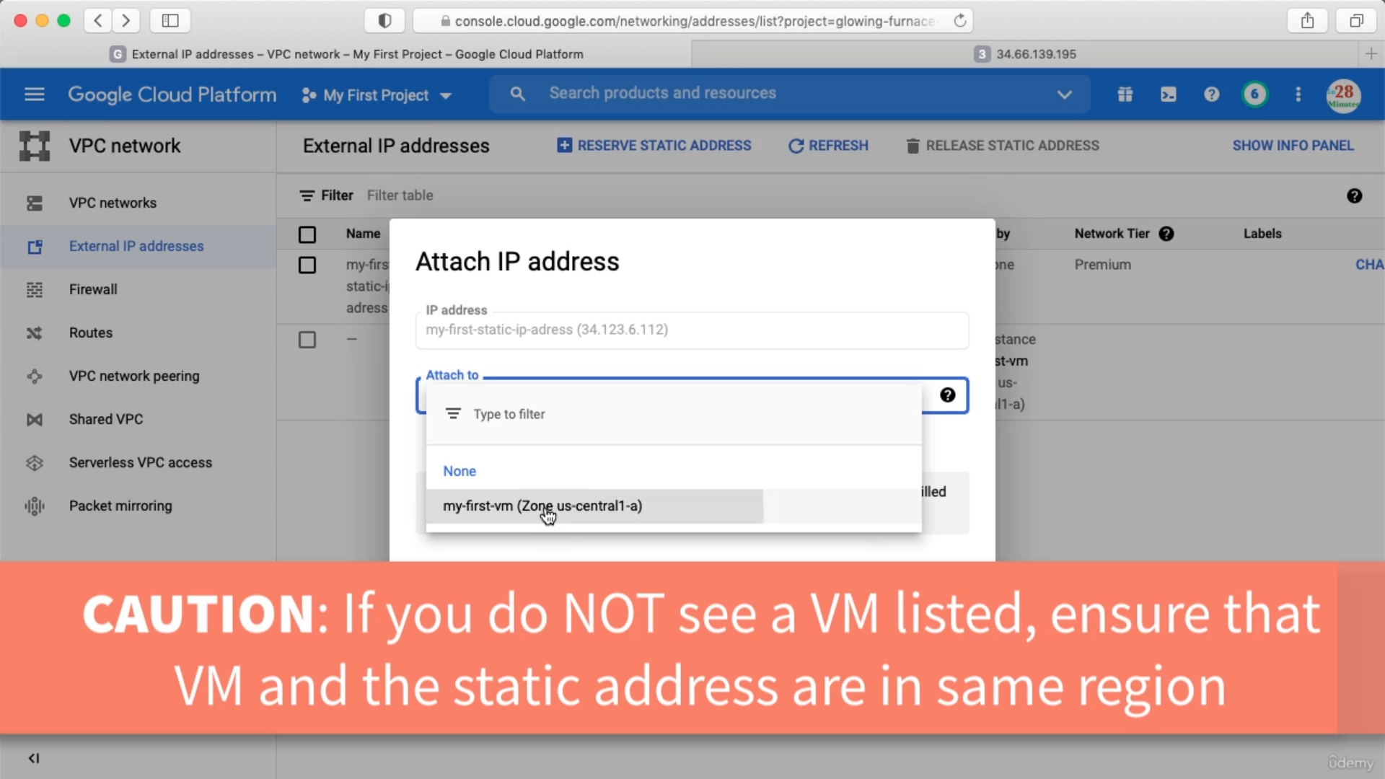

Now after refresh the ephemeral address will be released.

See VM instances

In Search type VM instances.

If we assign static address to our VM then even after stopping the VM the static address remains assigned.

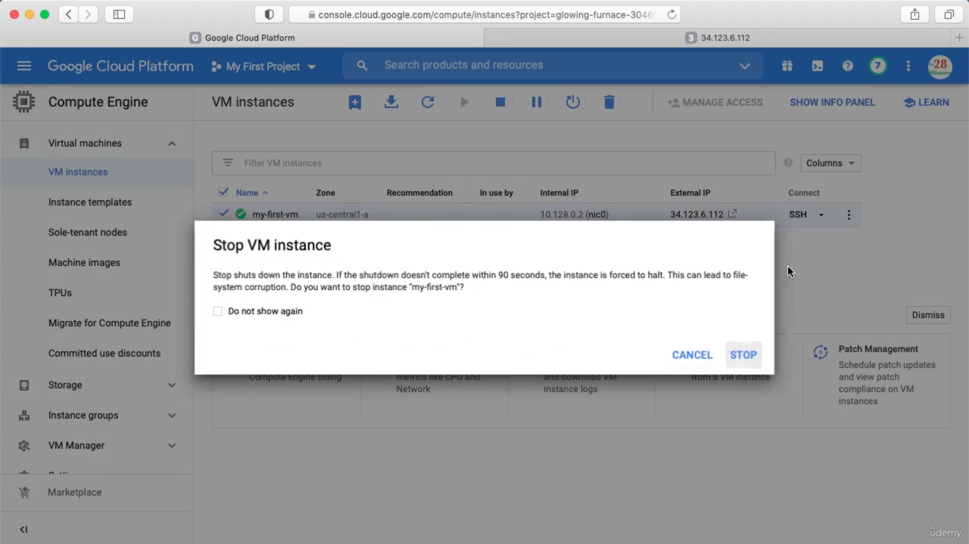

Releasing Static IP. You can delete the vm associated with this static IP.  
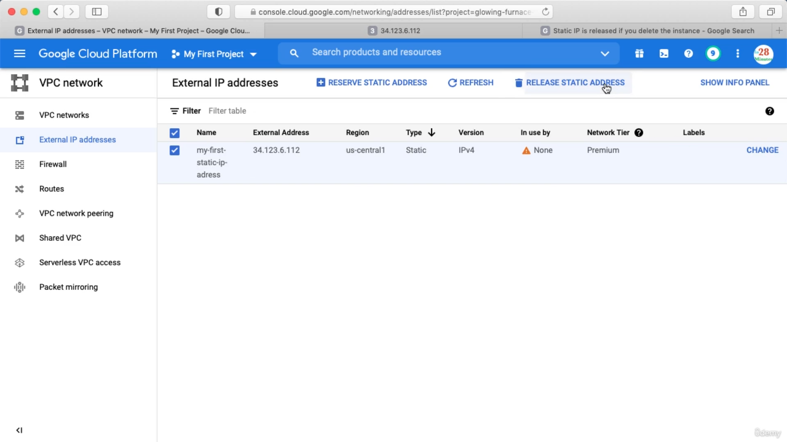

Creating VM instances with Start up Script.

In the Search box type VM instances and click create.

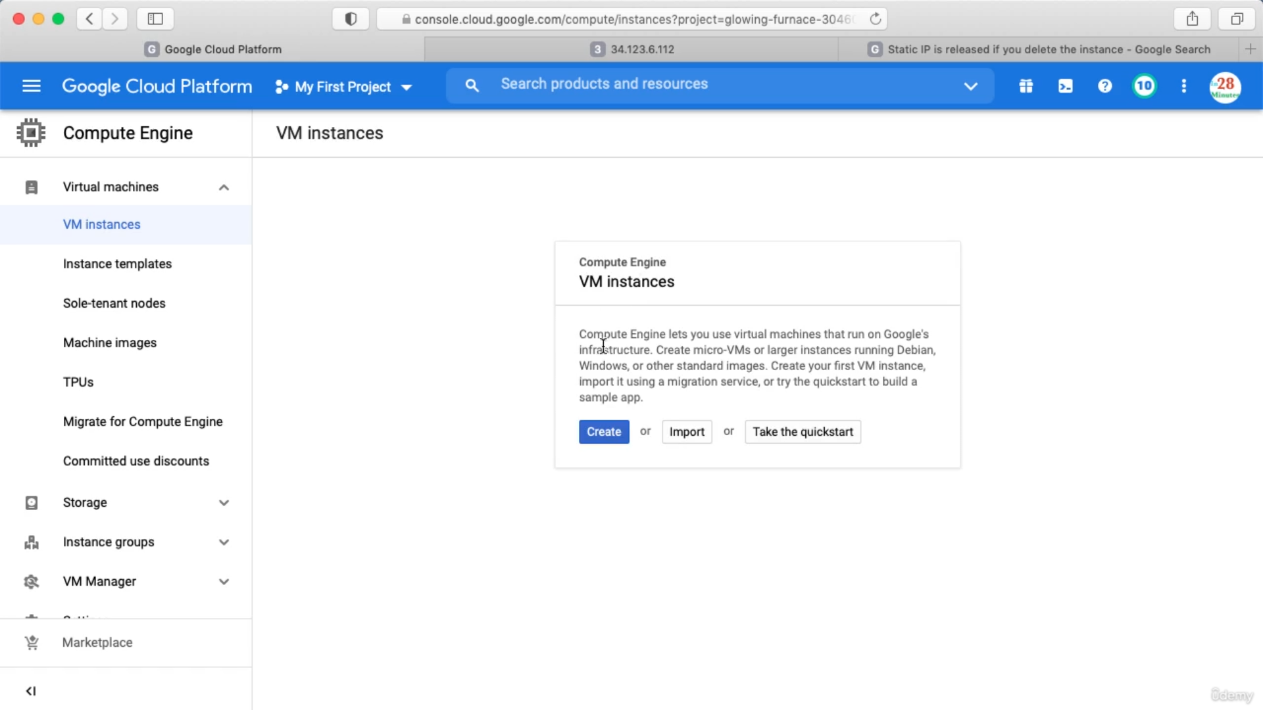

Label adds more information about the VM. Check Allow HTTP trafic for external uses.

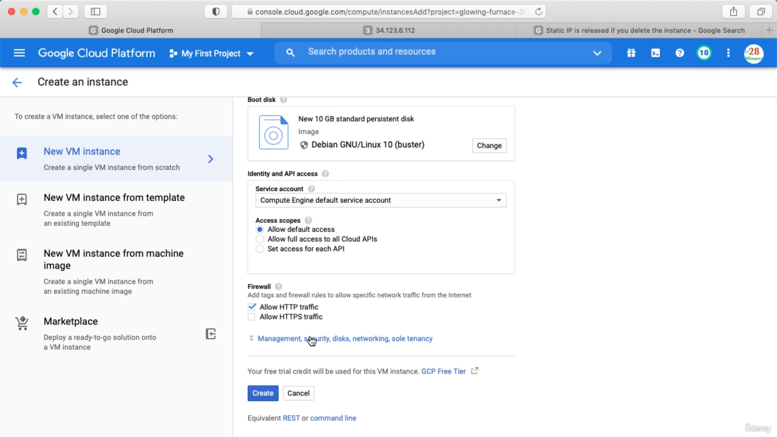

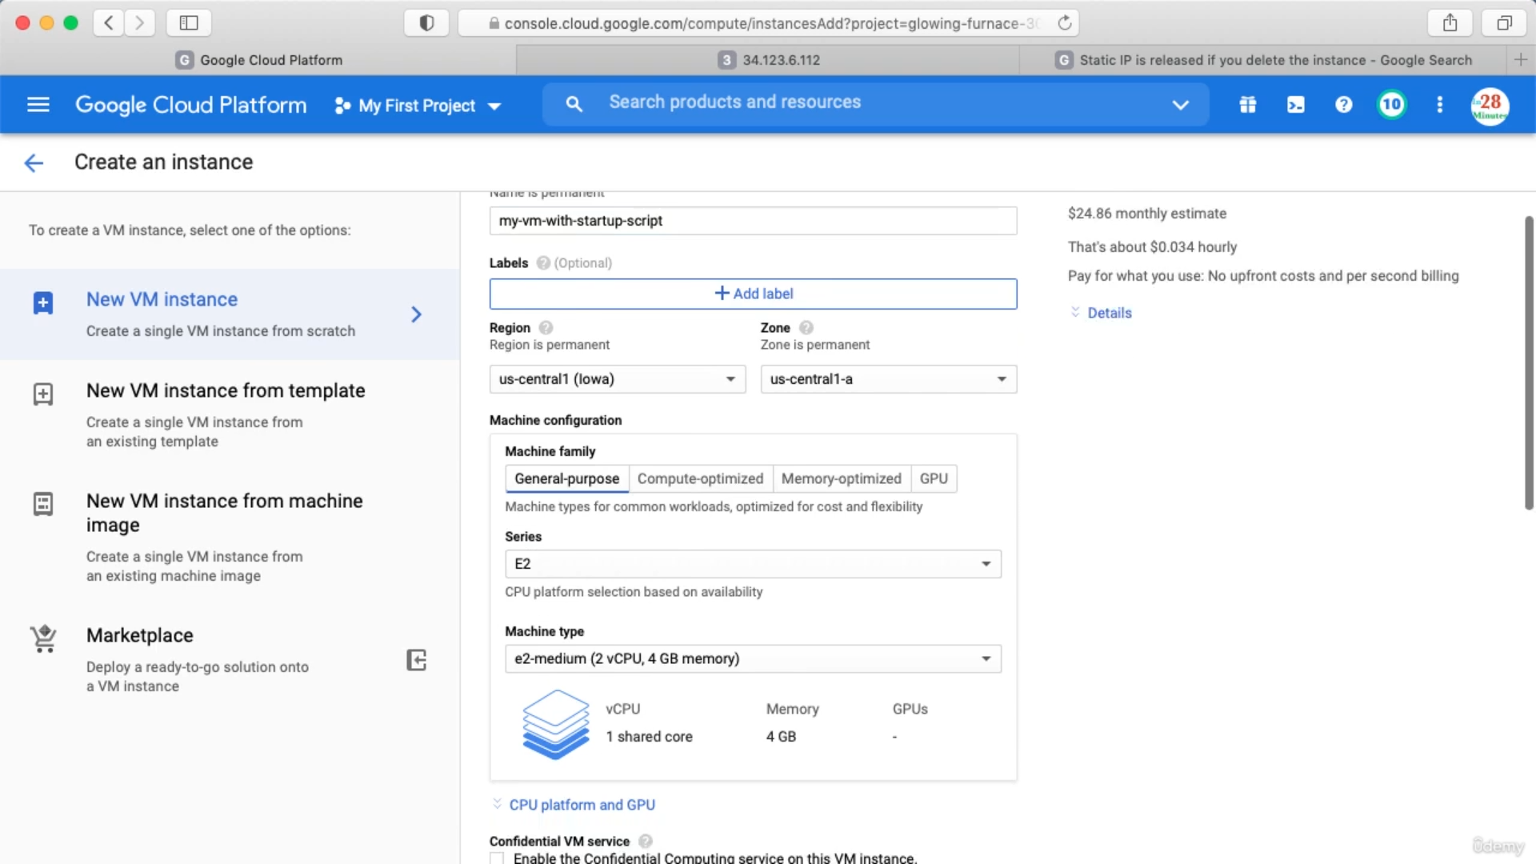

Click below

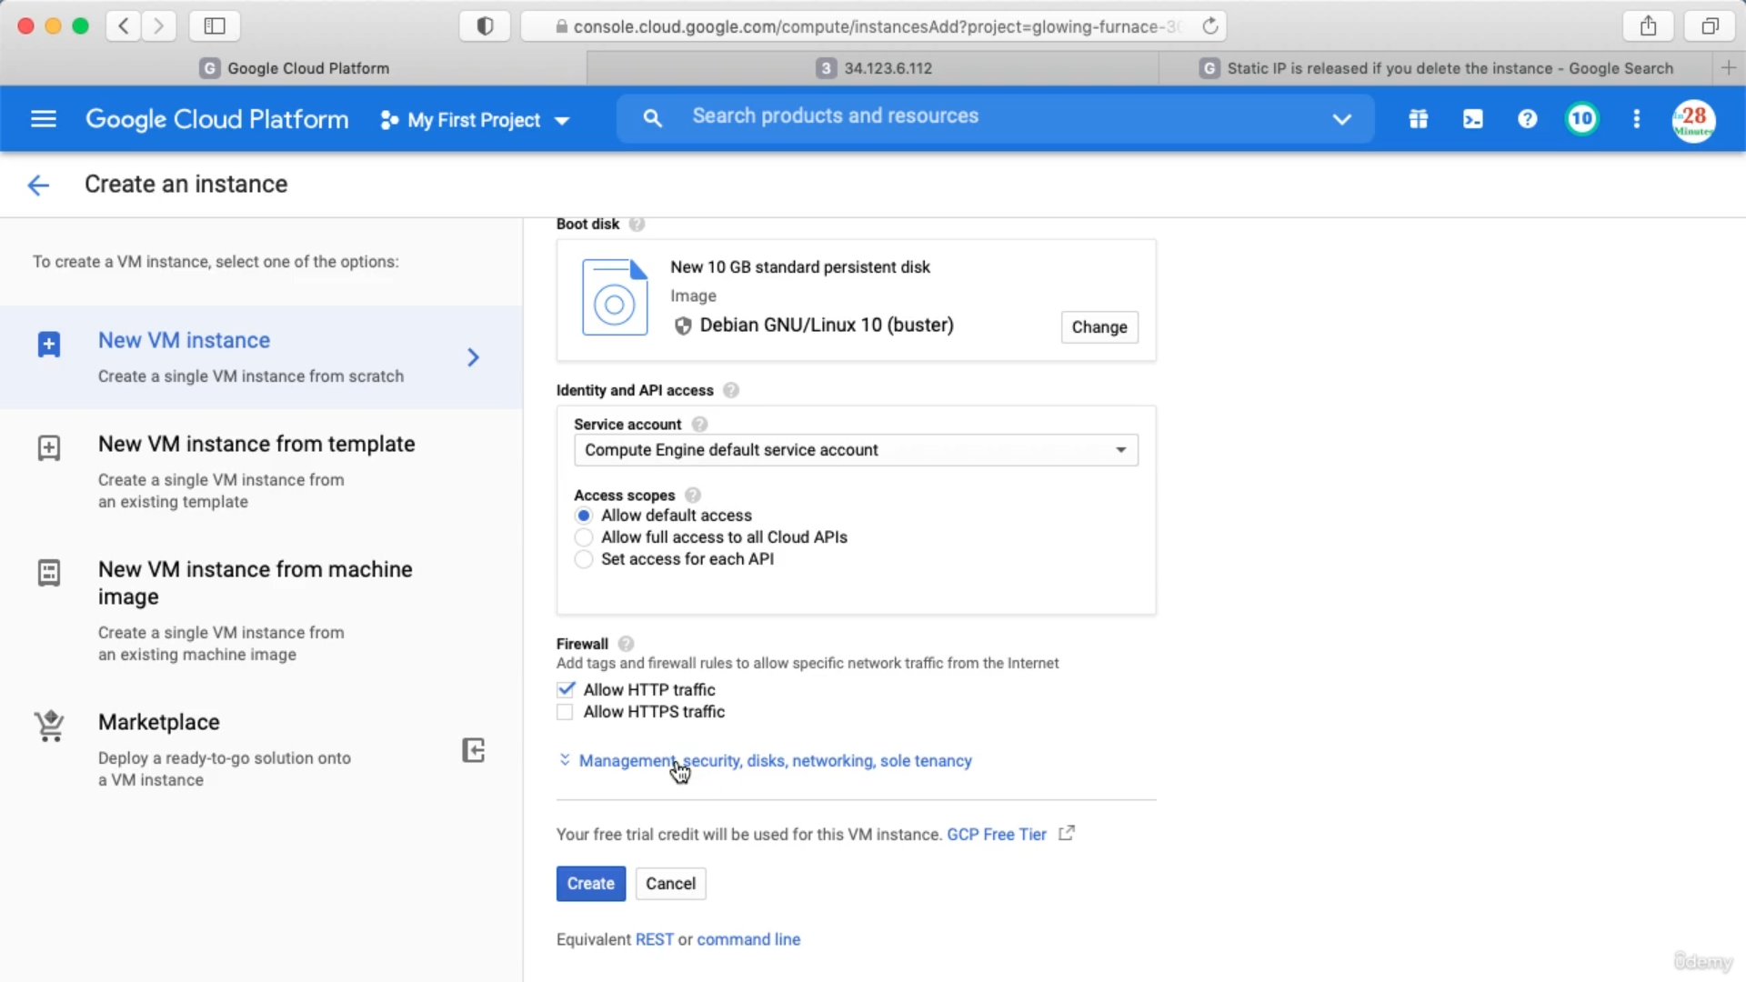

Add below in startup script

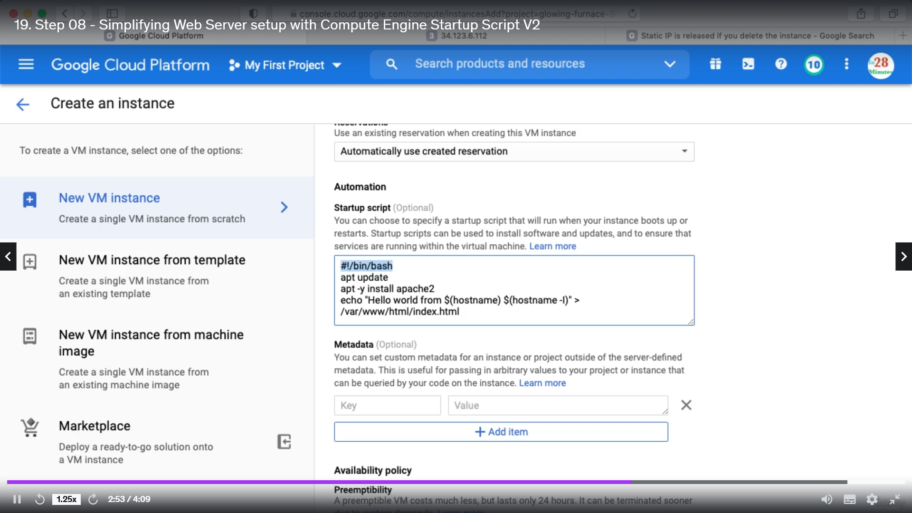

Now click create.

Creating VM using instance template

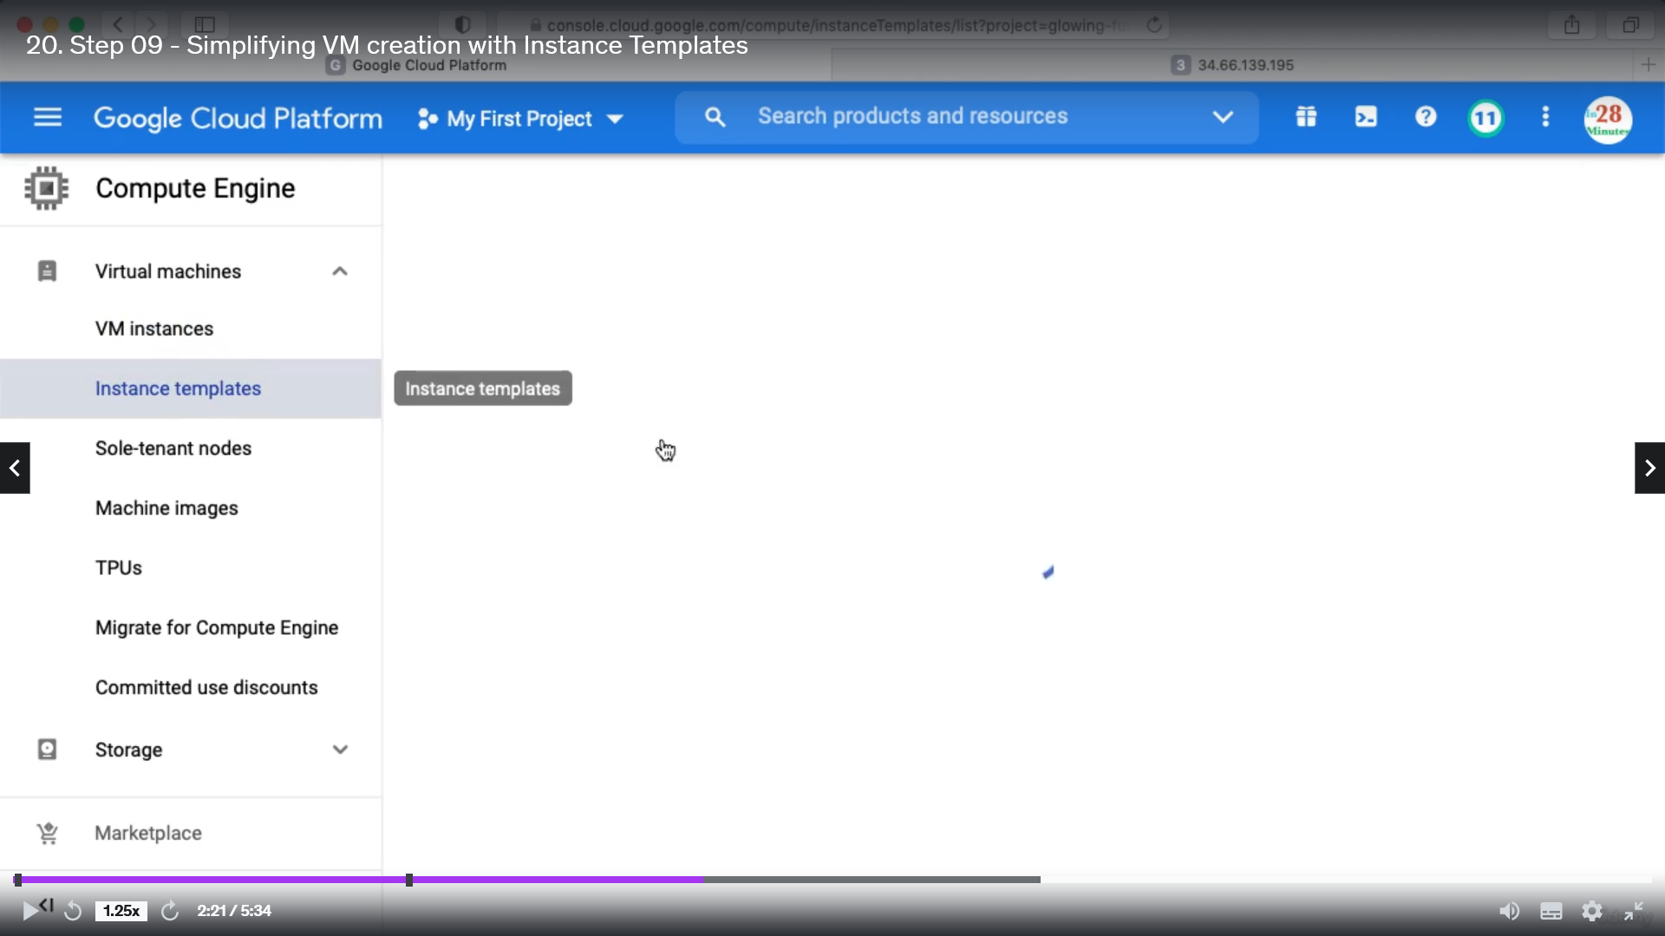

Fill up similar details and click create

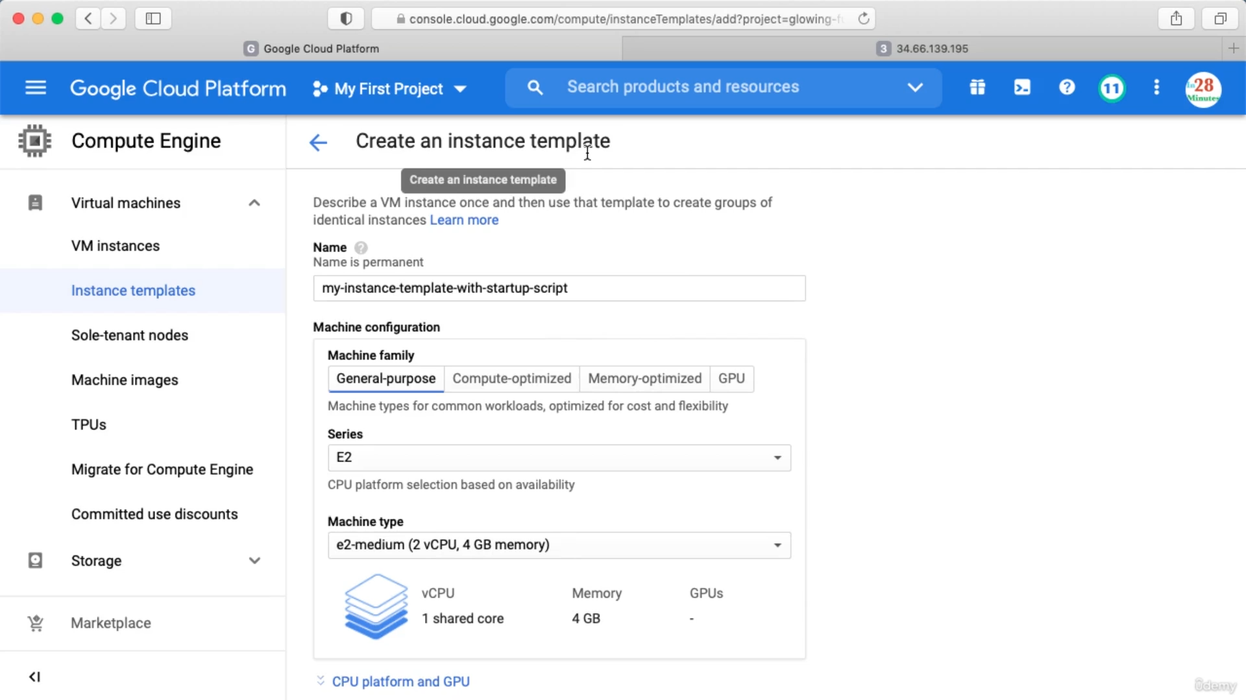

After creating below instance template will be created. There is no cost associated with instance template but when we create instance from instance template then cost will be deducted.

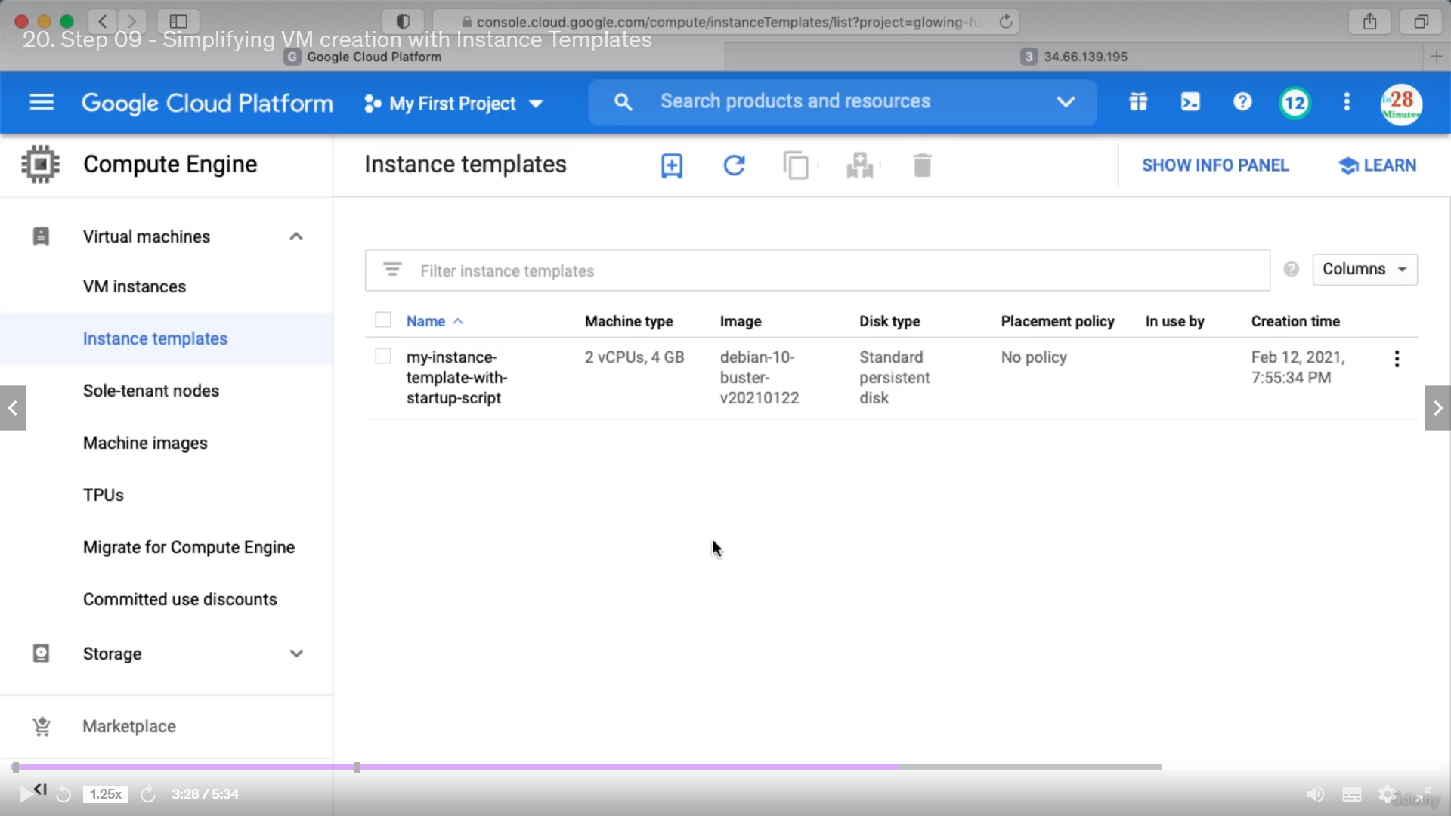

When creating instance template we do not specify Regions and Zones but while creating VM from template we specify Regions and Zones.

Create instance from instance template

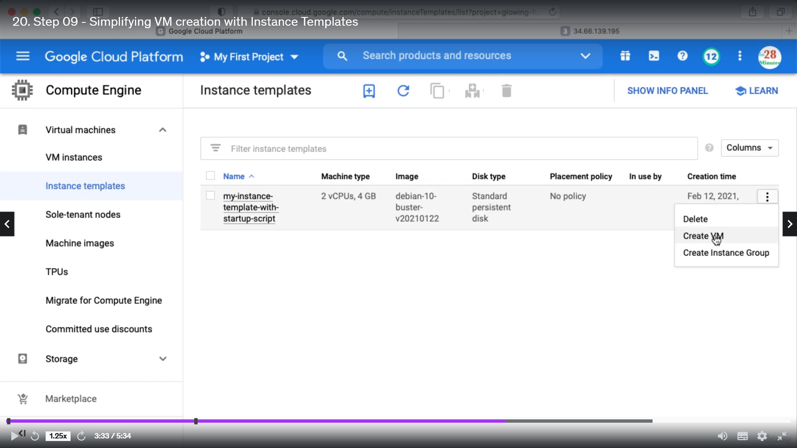

Then after selecting Region and Zone click create.

Reducing Launch Time

We can create image from an instance and then create VM from that image. This will reduce the launch up time.

Creating Custom image

If you click on Disk, you can see the Hard Disks associated with your virtual machine

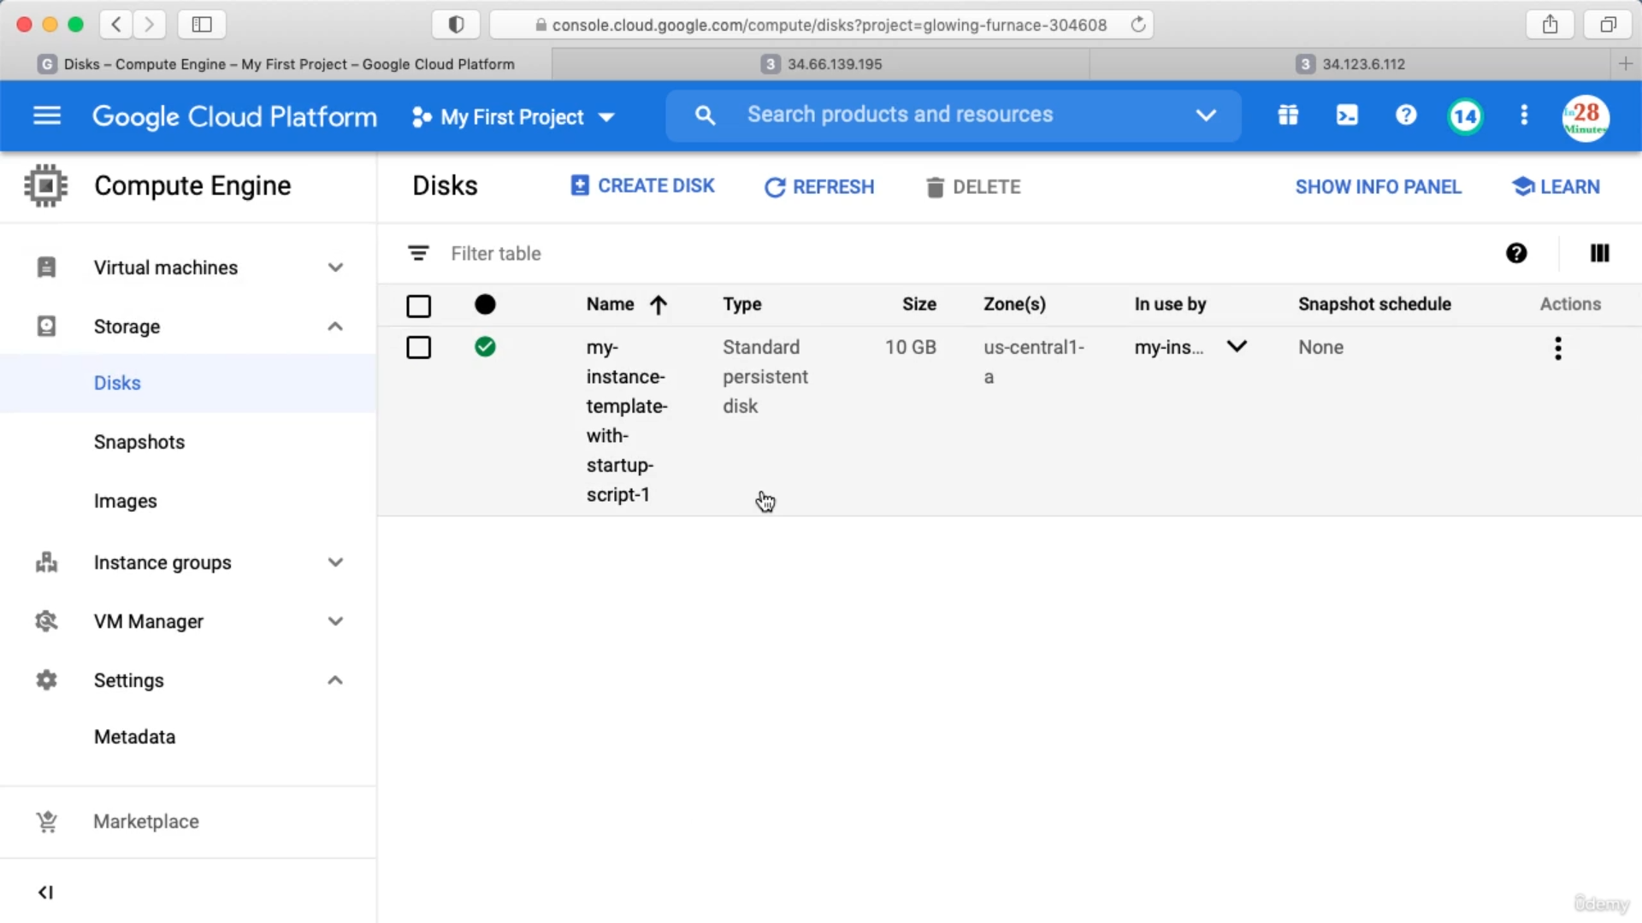

The name is same as the VM name. Click Actions and create image

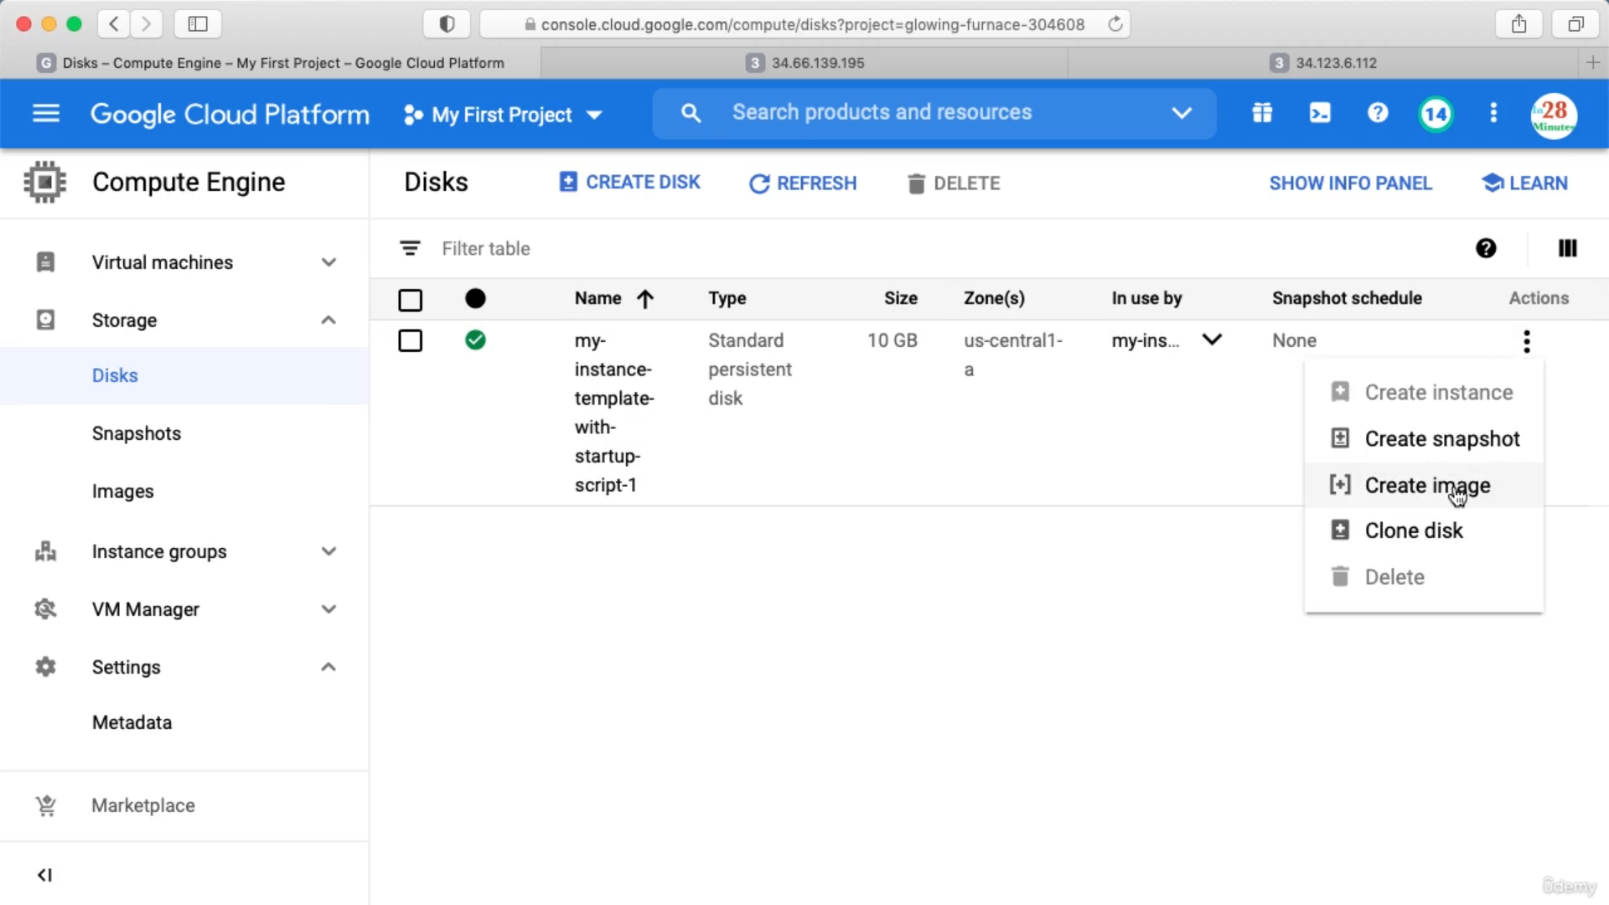

After this we need to select whether this image can be used to multiple region or a single region. Also we should not create any image from a Disk which is associated with a running instance.

Now from this image we can create a VM instance

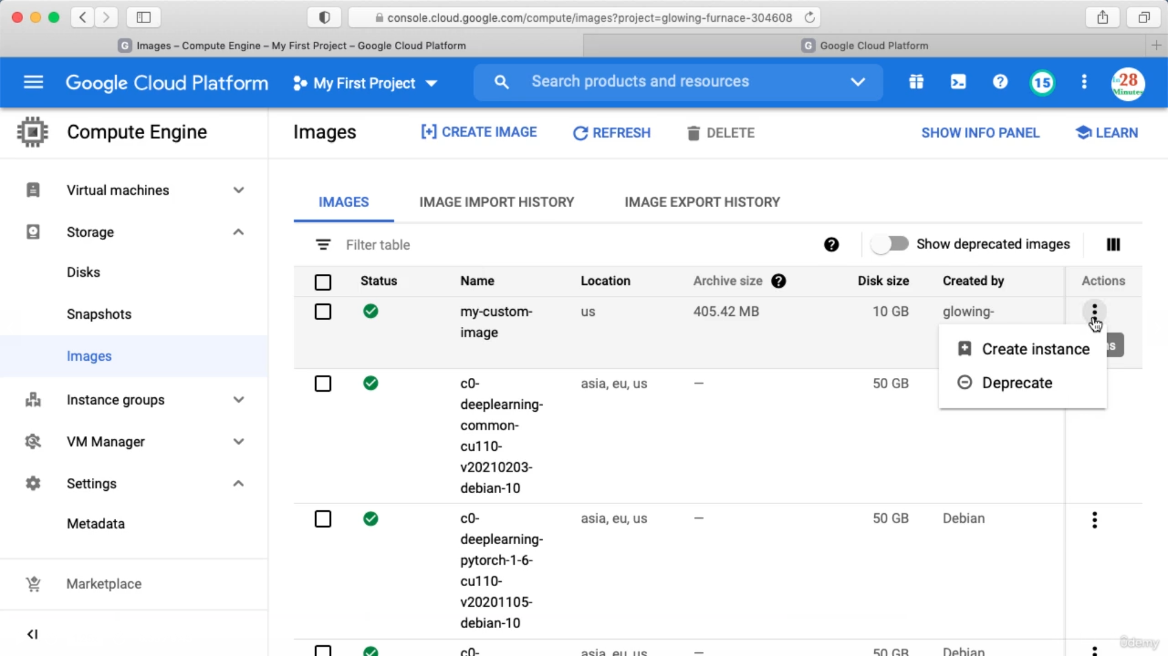

We can also create a instance template based on this image. Copy an existing instance template as below

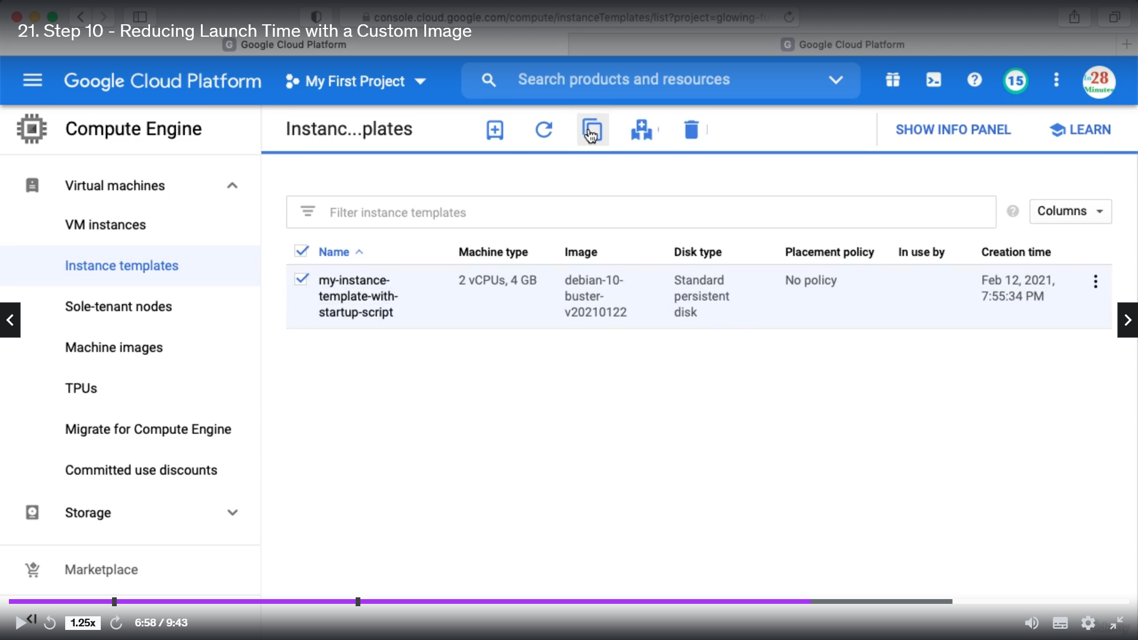

Rename the new template

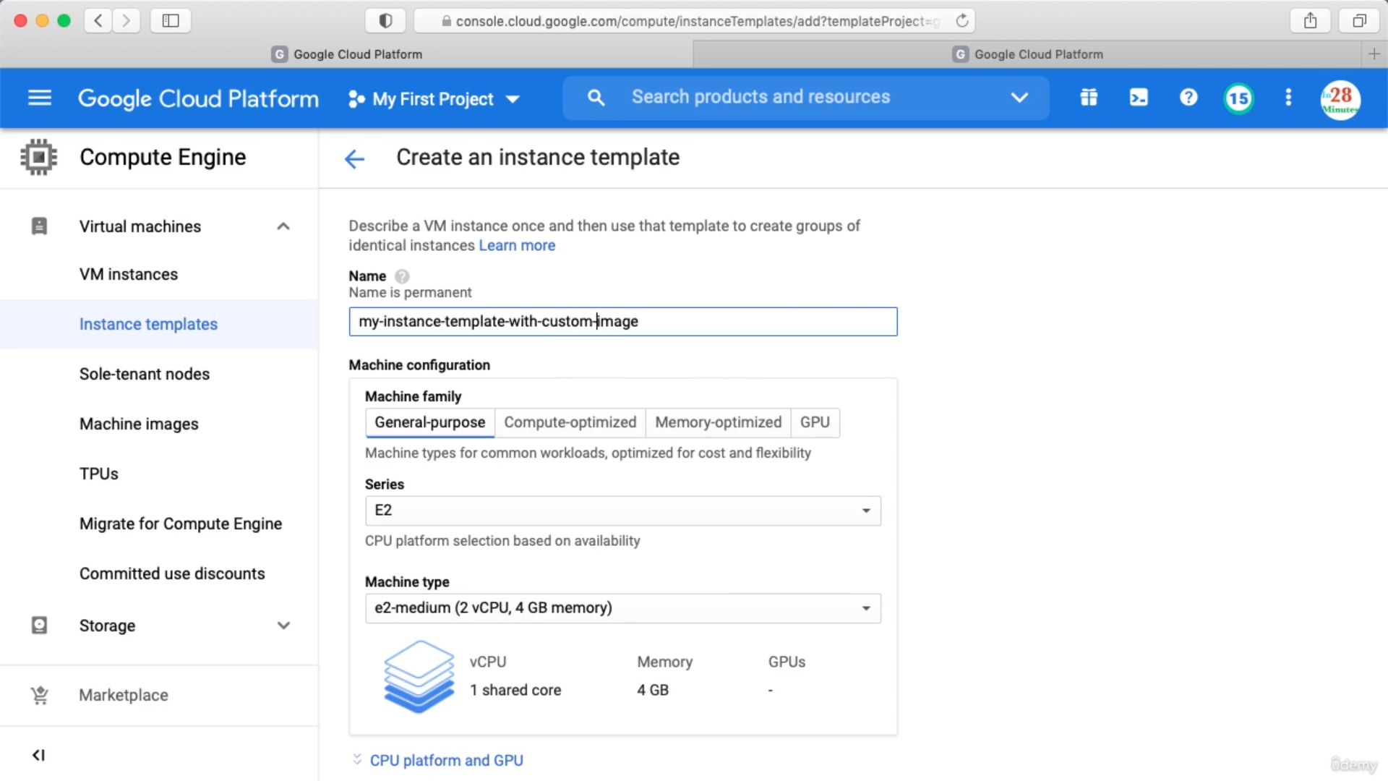

In the Boot Disk, change this to custom image

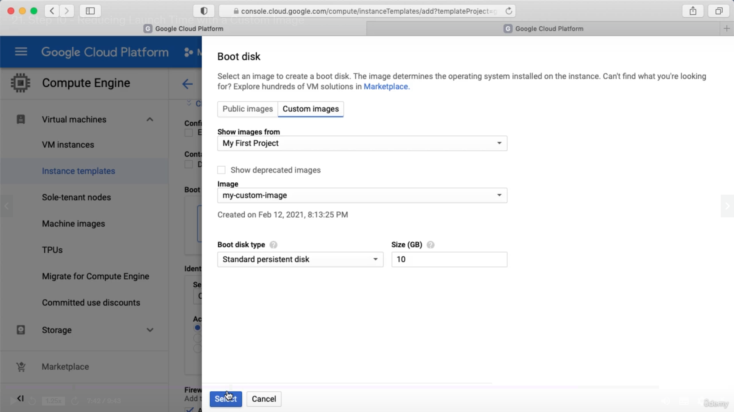

In the start up script we don’t need to install anything because apache is already installed in the custom image. Instead we need to start the service.

In the activity tab we can see whatever we are doing So far. We can filer this also.

